**1. Overview of the Company**

Infozium Solution PVT LTD has become one of the most dependable technology partners for a variety of industries, particularly in their digitization efforts. We believe the only way to bring change is to take action, thus, we use cognitive computing, hyper-automation, and emerging technologies to help our clients successfully adapting to the digital era. We have 100+ dedicated staff to serve clients across India & Overseas. Infozium Group is globally known for its comprehensive range of services, a strong commitment to sustainability, and excellent corporate responsibility. Together, we discover ideas and connect the dots to build a better and definite future.

**1.1 History of the Company**

Started Since 2011, our Co-Founder Mr Mitesh Lathiya left his high-paying job and took a risk & loan of 2 lakh Rupees to launch the Start-Up called Infinity, an I.T. services provider for few selected Indian & International clients. In 2014 Initial development & exposure stage provided the team enthusiasm & credibility to develop their own products and rename Infinity as PistaLix!. In 2017 With additional convenience, vital technical assistance, and comprehensive services, we have succeeded and decided to change the Pistalix solution to InFoZium.

**1.2 Different Product / Scope of Work**

Company have mainly 3 teams and first is Infizius which is provide mobile application service over the world wide and second is Xtripo travel which is companies own product it’s basically ERP for business and third is Playmax gaming which is provides gaming solution and create multiple games delivery to clients. Apart from these company is working on more own products for mobile and web.

**1.3** **More about Company’s Information**

The Infozium Group has established itself as one of the most sought-after technology partners in a variety of industries, especially in the context of digital transformation. By offering the best in our field, we have extended our Infozium Group in 3 different areas. We have a long-standing client who has been with us for many years, and our success is shown in our consistent and steady expansion of firms.

Achievements of Company:-

* Xtripo achieved IATA certification and Startupindia certification, a remarkable success within small time.
* Certificate of Accreditation By Infozium Solution PVT LTD

**1.4** **Company Vision**

Creating young Zinius for delivering futuristic growth with infinite technology services & solutions. The InFoZium Group is to achieve our group revenue of 1000 crores and group net valuation of 5000 crores by 2025 through supporting our clients with technical services & solutions beyond their expectations.

**1.5 Company Objective**

Clear standards and trust-based relationships are important to us since they enable us to enhance delighted customers and employees. By continues, collaboration with the customer helps us to deliver innovative & customer-centric solutions on time. Always Make Client happy with Satisfactory project delivery and give some extra benefits over the delivery of product make client more happy and growth the company revenue and market. Working on more companies products which are solve the B2B Business problems with create multiple platform application and website.

**2. Overview of different department of the organization and process being carried out in company**

The Infozium Group has established itself as one of the most sought-after technology partners in a variety of industries, especially in the context of digital transformation. By offering the best in our field, we have extended our Infozium Group in 3 different areas. That ares Mobile application, Web application, Gaming We have a long-standing client who has been with us for many years, and our success is shown in our consistent and steady expansion of firms.

**2.1 Departments**

At our company there are Many departments.

* Mobile Application Department - Infizius Team
* Web Applications Department - Xtripo Travel Team
* Gaming Department - Playmax Gaming Team
* Marketing Team – BDM Team

**2.1.1 Mobile Application Department**

We provide a comprehensive solution and everything you need to develop your own mobile app (Android & iOS) without any coding knowledge!

Infizius has extensive experience developing high-performing, digitally transformational, and feature-rich mobile apps for all major mobile platforms.

It doesn’t matter if it’s an Apple, Android, or hybrid device. We have digital Einstein developers who can construct dynamic, high-quality mobile apps for a variety of platforms.

All you have to do now is pick from our collection of high-quality, ready-to-use web & app templates and let our team of experts handle the rest.

**2.1.2 Web Applications Department**

Xtripo has revolutionized the travel industry. We tailor end-to-end travel services, such as selecting and arranging acceptable flights before moving on to hotel stays. We have dominant hotel affiliations all over the world, allowing us to give the best value for our customers’ money. We have a skilled team that will respond to your questions as quickly as possible. Our staff will research the greatest vacation packages available, sort through cruise packages, and complete your entire trip in one go.

**2.1.3 Game Department**

Playmax Gaming is one of the world’s fastest-growing game development company. As a leading game design and development firm, Playmax can be your one-stop shop for all of your game development needs. Among the services we provide are conception enhancement, character customization, graphics and animation, game mechanics, coding, and testing.

**2.2 Steps to Complete a Project**

Most of the time company is using Automatic scanning tools for the small size of the project, but when the project is at large scale, company use agile methodology. Company is mainly focus on the deadline achievement. Our first priority when a project is assigned is that to complete the task in a given time and weeks.

**2.3 Sequence of Operation**

Requirement analysis is the most important and fundamental stage in Application Testing . It is performed by the senior members of the team with inputs from the hackers, the sales department, market surveys and domain experts in the industry. This information is then used to plan the basic project approach and to conduct product feasibility study in the economical, operational and technical areas.

Planning for the quality assurance requirements and identification of the risks associated with the project is also done in the planning stage.

After successfully complete security testing face they generate report bas on application testing. Send that report to that client and explain about web applications weakness and it’s bad impact. The outcome of the technical feasibility study is to define the various technical approaches that can be followed to implement the project successfully with minimum risks.

**3. Introduction to Internship**

The internship program is designed to provide students engaged in a field experience with an opportunity to share their insights, to explore the links between students' academic preparation and their field work, and to assist participants in developing and carrying out the major research project which will serve to culminate their internship experience.

Internships are individualized and tailored to the needs and interests of each student in the program. As part of the internship experience, students are expected to take an active role in finding an appropriate internship for themselves. Many students pursue their own contacts, however, information is available on Locating Internship Sites.

**3.1 Internship Summary**

To experience the practical working of what we studied in the book theories, is very interesting, memorable and very important in our education. Doing internship is my first experience of working for any company and learn how the things are being done in the actual industry. It was very memorable and everlasting experience of doing an internship. I have done internship in Evolution info secure, Surat. It was 12 weeks long.

My Internship was excellent with full of hands on Experience. Learning a lot from the leader and company work culture how to deal with client and how to structure project. In Starting weeks Learning Node Js course from Udemy. Create Multiple APIs in Nodejs for learning purpose and worked on the warehouse management project. Overall Experience was Good learn and solve a lot’s from Real world problem and Projects solution.

**3.2 Purpose of Internship**

* Main Purpose of an Internship that I wanted to learn new technologies which are use by the companies Nowadays and the real or hands on work within the company and team.
* Internship is good things though which a we can see how Actual or Real work done in companies and what are client requirement and how to deal with them it’s a good experience that I want to pursue during Internship Period.
* My believe that Internship or Training and learn from Expert make growth success and under the work in senior developer will teach us to solving any kind of project and solution of any problem that I want to learn from Internship.

**3.3 Objective**

* Apply skill concepts and theories to real-world decision-making
* Increase knowledge in are such as operations management, Website design and development , provide creative solution to client.
* Develop and improve skills in communication, technology, quantitative reasoning, and teamwork.
* Observe and participate in operations and decision-making will make confidence and Interest .
* Meet professional role models and potential mentors who can provide guidance, feedback, and support.
* Expand network of professional relationships and contacts.
  1. **TECHNOLOGY AND LITERATURE REVIEW**

**3.4.1 Nodejs**

* MySQL

**3.5 Scope of Internship**

* Gain knowledge from Internship and Industry Experts.
* An Internship Provides Real Life Experience and Exposure.
* Deal with Clients and find Solution of any project
* Get Connected and Develop Your Professional Network
* The Opportunity To Learn More About Yourself

**3.6 Internship Scheduling**

Table 3.6.1 During January

|  |  |  |  |  |
| --- | --- | --- | --- | --- |
|  | Week-1 | Week-2 | Week-3 | Week-4 |
| Introduction of Company and Node Js |  |  |  |  |
| Node Js Training |  |  |  |  |
| Node Js Training and Implement Some Demo Tasks |  |  |  |  |
| Node Js and MySQL Training |  |  |  |  |

Table 3.6.2 During February

|  |  |  |  |  |
| --- | --- | --- | --- | --- |
|  | Week-1 | Week-2 | Week-3 | Week-4 |
| Research and started planning of warehouse project. |  |  |  |  |
| Starting Implementation of Warehouse Management project |  |  |  |  |
| Implement APIs on manager, Delivery person |  |  |  |  |

Table 3.6.3 During March

|  |  |  |  |  |
| --- | --- | --- | --- | --- |
|  | Week-1 | Week-2 | Week-3 | Week-4 |
| Implement APIs on Order in Warehouse Project |  |  |  |  |
| Implement Report APIs in Warehouse  Project |  |  |  |  |
| Started Working on battleship game project |  |  |  |  |
| Build APIs on battleship game project |  |  |  |  |

**4. Approach and Methodology**

SecurityBot conducted the assessment using its own hybrid method, operated by OWASP, SANS, and NIIST. Best practices. Security bot complies with vulnerability assessments and penetration tests To meet the needs of the organization and to help the organization identify high business Risk vulnerabilities within the scope of the work provided. The following section describes the approach and Methodology used by the SecurityBot team.

**4.1 Identification of Vulnerability**

Identify the risks and vulnerabilities that may affect the project or its outcome. We test against it Test cases owned by Owasp, Sans, NIIST, as well as SecurityBot, so the company could be the team assured that the latest, most prevalent and cost-effective web application will be vulnerabilities identified. A general overview of our method is as follows.

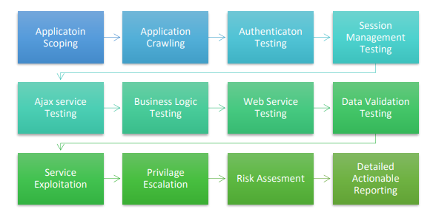

Fig 4.1.1 Identification of Vulnerability

**4.2 Analysis of the Vulnerability**

Once the vulnerabilities have been identified, we determine the probability and outcome of each vulnerability. We develop an understanding of the nature of the vulnerability and its potential to affect technical as well as business objectives.

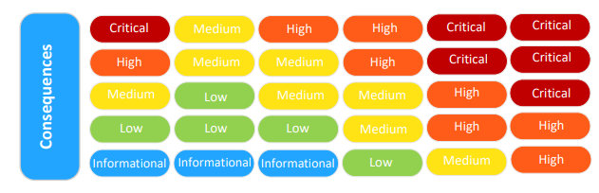

Fig 4.2.1 Vulnerability Analysis

**4.3 Evaluation of the Vulnerability**

Having understood the vulnerability, the next step is to rank or evaluate the severity, likelihood, and outcome of the risk by combining it. On a scale of 5-level intensity, ranks vulnerabilities from informational, low, medium, high and critical. In addition, this report not only provides a conclusion, but also suggests that vulnerability is acceptable or severe enough to require treatment.

The following priority matrix was used to classify the structure of CANVAS assessment Findings

Table 4.3.1 Evaluation Table

|  |  |  |  |
| --- | --- | --- | --- |
| **Priority Level** | **Severity Scale** | **CVSS Score** | **Description of Vulnerability** |
| P1 | Critical | 9.0-10.0 | Vulnerabilities that affect all users of the  platform, and /or affect the security of the  platform or host system |
| P2 | High | 7.0-8.9 | Vulnerabilities that affect more than one user of  the platform, and that require little or no user  interaction to trigger. |
| P3 | Medium | 4.0-6.9 | Vulnerabilities that affect more than one user  but may also require interaction or a specific  configuration |
| P4 | Low | 0.1-3.9 | Issues that affect singular users and require  interaction or significant prerequisites (MITM)  to trigger |
| P5 | Informational | 0.0 | Issues that leaking very basic information which  might lead to information disclosure |

**5. SYSTEM DESIGN**

**5.1 Usecase Diagram**

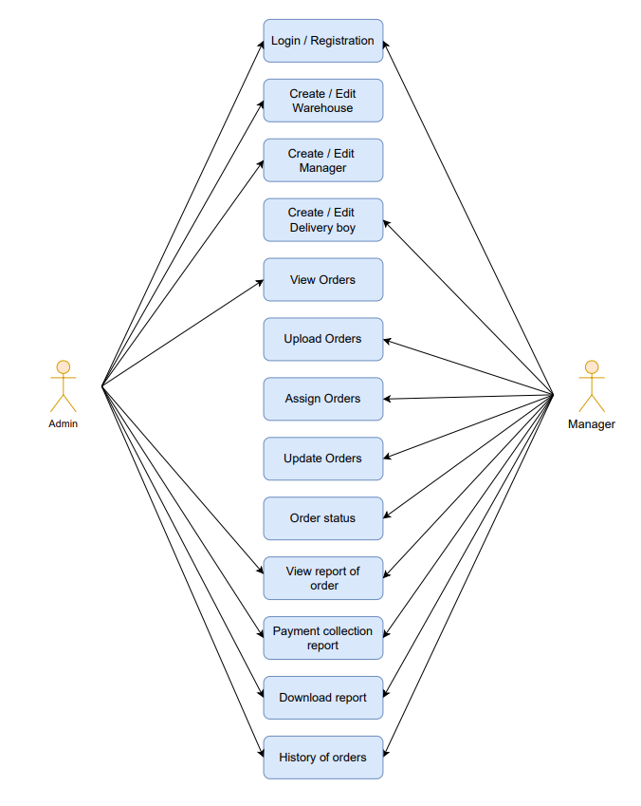

Fig 5.1 Use case Diagram

**5.2 Activity Diagram**

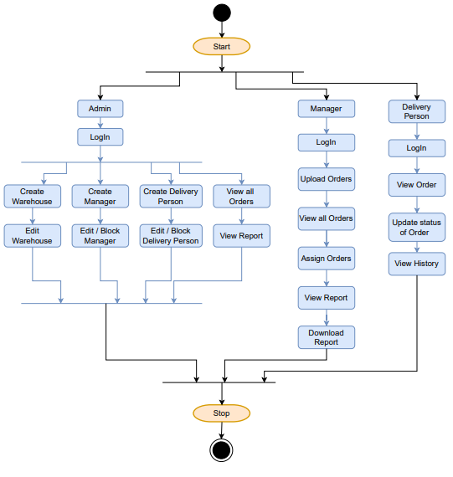

Fig 5.2 Activity Diagram

**6. IMPLEMENTATION**

**6.1 IMPLEMENTATION PLATFORM**

This project is a web app-based systems so the following tools is used to develop the proposed appication.

Tools and Platforms used to implement are:

* Visual Studio Code
* MySQL
* Postman

**6.2 MODULE SPECIFICATION**

I have been assigned to the following modules in this project:

**6.2.1 Admin Create Warehouse Manager and Delivery Person**

In this module I’ve developed APIs for Create, Edit, Block the Warehouse, Warehouse Manager, Delivery Person.

**6.2.2 Manager can upload order and assign order**

In this module I’ve developed APIs for manager can upload orders, view all orders, view assign orders, delivery type of orders, assign orders to delivery person.

**6.2.3 Admin and Manager can view reports of orders**

In this module, I’ve added APIs for manager and admin can check the status of order by particular Delivery person and the from and to Date and also download the payment collection report.

**6. Conclusion and Discussion**

**6.1 Overall analysis of Internship**

I felt that an internship at my company was a great platform for me to gain deeper insights into the Web application security testing . My Company is also known for its focus on diversity as well as career development programmers which I believe provide numerous learning opportunities for the interns.

**6.2 Date of surprise visit by institute mentors**

* Visit 1:- 17th FEB 2022
* Visit 2:- 21st MAR 2022

**6.3 Date of Continuous Evolution (CE-I AND CE-II)**

* Continuous Evaluation 1:- 19th FEB 2022
* Continuous Evaluation 2:- 21st APR 2022

**6.4 Summary of Internship**

To experience the practical working of what we studied in the book theories, is very interesting, memorable and very important in our education. Doing internship is my first experience of working for any company and learn how the things are being done in the actual industry.

This internship has been an excellent and rewarding experience. During this internship I know about web application scanning tools like BurpSuite, ZAP, Nessus, Metasploit, Nmap etc. Also know about network pentesting and firewall testing at basic level. Apart from that I learn a lot’s of testing tools and hands-on experience on testing on client’s web application.

I crate education continent related in cyber security field. I also participate on live webinar.

I take part in VAPT(Vulnerability Assessment and Penetration Testing) program on hackerone also take part in private bug bounty programs and find some vulnerabilities during my internship period.

**References**

1. [A case study on web application security testing with tools and manual testing | IEEE Conference Publication | IEEE Xplore](https://ieeexplore.ieee.org/abstract/document/6567420?msclkid=c6e143a5c2cf11ec8bd07e182d2a5c3b)

2. [OWASP Web Security Testing Guide | OWASP Foundation](https://owasp.org/www-project-web-security-testing-guide/?msclkid=24182904c4b211ecb2fa9c66ce0186e5)

3. [OTGv4.pdf (owasp.org)](https://owasp.org/www-pdf-archive/OTGv4.pdf?msclkid=24189d5cc4b211ec9710f479fe18b591)

4. [Apache Logging Basics - The Ultimate Guide To Logging (loggly.com)](https://www.loggly.com/ultimate-guide/apache-logging-basics/)

5. [Log analysis for web attacks: A beginner's guide - Infosec Resources(infosecinstitute.com)](https://resources.infosecinstitute.com/topic/log-analysis-web-attacks-beginners-guide/)